Notas IA generadas por Teams

Notas de la reunión
Contraer todo
Centralized Assay And Shipment Workflow: SAFSA-TRN-Sj-SanJulian explained to LUIS and JORGE that the team needs a centralized system to replace truck-by-truck Excel processing for concentrate sampling, laboratory assays, shipment reporting, and review controls.
.
Current Sampling Process: The current process weighs and samples concentrate shipments truck by truck. Individual truck samples are combined into composite samples for the relevant lot, while the team may retain truck-level information for analysis and reference. The process applies to concentrates such as lead and zinc and involves information from the mine, laboratory, and receiving or destination units.
.
Excel-Based Reporting: Shipment, sample, laboratory, and assay information is currently transferred and reviewed through Excel files. SAFSA-TRN-Sj-SanJulian described this manual flow as difficult to control across the different stages and susceptible to reporting or transcription errors.
.
Desired Automation: The requested solution should capture information from the existing preferred tool, route it through a review workflow, and provide visibility into changes and approvals. The system should reduce manual entry and allow users to follow the status of samples, lots, results, and reports from one place.
.
Shipment Search Criteria: The demonstrated shipment reporting flow supports searches by operating unit or company, product, client, destination, warehouse, and a defined date range. The report can be generated for selected shipment information and exported in PDF or Excel format.
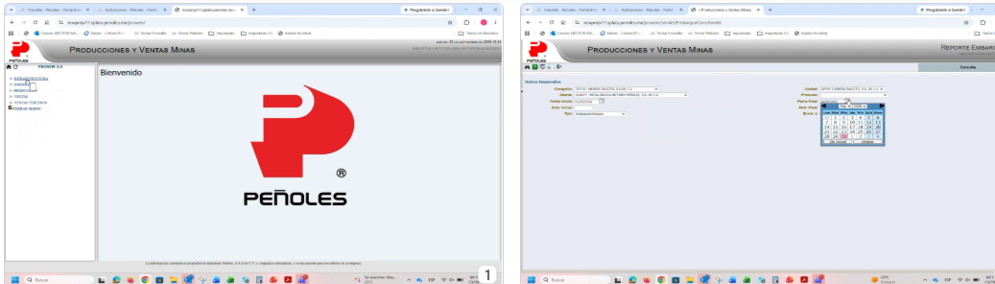
Lot Closure And Weighted Assays: SAFSA-TRN-Sj-SanJulian described how closed lots should aggregate shipment weights and assay values, distinguishing mine results, client results, and the applicable composite or weighted calculation.
.
Lot-Level Reporting: Closed-lot reports group shipments by lot and display dates, customer, unit, product, wet and dry weights, differences, and assay elements including gold, silver, lead, copper, zinc, arsenic, iron, cadmium, antimony, mercury, and related measures.
.
Weight Calculation: The total lot weight is calculated as the sum of the weights of the trucks that make up the lot, including the applicable mine and receiving-unit records. SAFSA-TRN-Sj-SanJulian identified this total as the basis for weighted element calculations.
.
Weighted Results: The system should calculate weighted assay values for the lot rather than treating every truck result as an independent final result. The discussion distinguished weighted values from average values and indicated that the calculation should be available by element and by lot.
.
Result Sources: The process compares or reports results from the mine, the customer or receiving unit, and third-party analysis where applicable. The report must preserve the source and context of each result so users can determine which value is used for settlement or comparison.

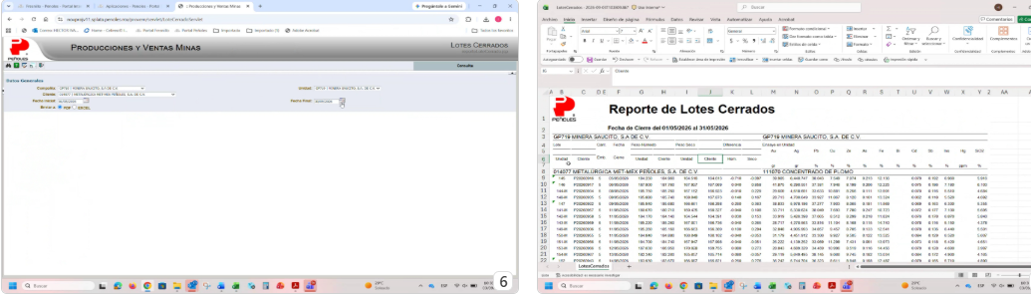
Data Standardization And Traceability: SAFSA-TRN-Sj-SanJulian identified unit, date, lot-number, and correction controls needed to make assay and shipment data consistent and traceable across systems.
.
Unit Conversion: The discussion identified inconsistent reporting units, including kilograms per tonne, grams per tonne, and related assay representations. The system must standardize or clearly convert units so that values such as silver and other assays are reported consistently in the required format.
.
Automatic Identifiers: The proposed workflow should automatically carry key identifiers such as the lot number, mine or unit, customer, product, and sampling or entry information. This would reduce repeated manual capture and support retrieval of the complete record.
.
Date Traceability: SAFSA-TRN-Sj-SanJulian requested that sample, result-entry, and update dates be captured automatically where possible. If a result is corrected, the system should retain the original context and add or preserve an update date rather than obscuring the history.
.
Controlled Corrections: The workflow should show who entered or authorized reported values and which steps are defined or variable. Corrections and modifications need to remain visible for review, with an audit trail covering the change and its authorization.
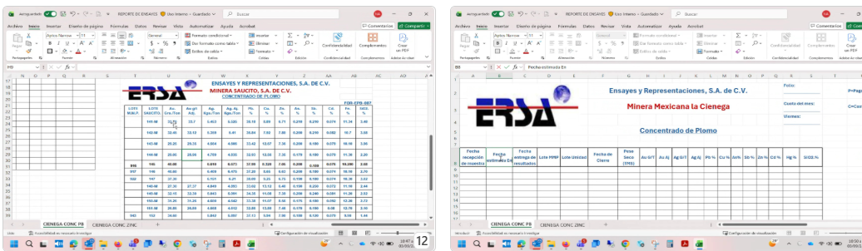
Third-Party Reconciliation Process: SAFSA-TRN-Sj-SanJulian explained that third-party results must be compared with mine and customer results through reanalysis, contractual limits, and settlement calculations.
.
Comparison Workflow: When mine, customer, and third-party assays differ, the team compares the results to determine the applicable value and whether the difference is within the contractual partition or tolerance limits. The comparison is performed by lot and by element.
.
Reanalysis Handling: A reanalysis may be requested when a third-party result or another assay falls outside the expected range. The system should record the initial result, the reanalysis, and subsequent analysis-in-conjunto or comparable results as separate events.
.
Example Review: The demonstrated reconciliation example showed multiple gold and silver values from different sources, including a first third-party result, a reanalysis, a joint analysis, and a later analysis. The records also displayed differences versus the third party and the value used for payment.
.
Settlement Calculation: The final exchange or settlement calculation should use the applicable assays for the lot and element, not necessarily every available result. The workflow should identify which results are signed or accepted and retain the supporting comparison history.
.
Out-Of-Range Results: The process includes identifying results outside an agreed range and determining the next action, such as an additional analysis or review. The system should make these exceptions visible rather than allowing them to remain only in a manually maintained spreadsheet.
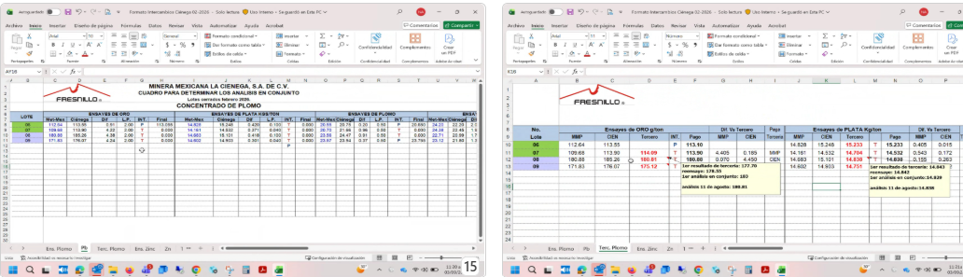
Portal Reporting Demonstration: SAFSA-TRN-Sj-SanJulian demonstrated the existing portal views for shipment reports and closed lots, including filters, destinations, date ranges, and downloadable outputs.
.
Shipment Report Filters: The portal includes company or unit, product, final date, final shipment, destination, and date-range fields. The demonstrated report can be narrowed to a selected customer or destination and generated for a defined period.
.
Export Options: The shipment report interface provides PDF and Excel output options, allowing the resulting report to be distributed or further reviewed.
.
Closed-Lot View: The closed-lot interface provides a date range and unit or customer selection and presents the resulting lot records with assay and weight information. This view is the operational reference for lots that have completed the relevant process.
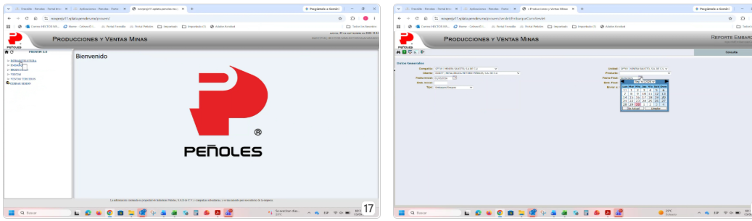

Notas de Sonia
Expectativa: terminar todo para el 27 de octubre. Carlos nos acaba de comprometer.

PB y ZN
En la unidad camión por camión.
Pagables y castigables.
Lims?Lins?Por guía en PROVEM.

LOTE VARIOS CAMIONES
En Peñoles lo reciben pero lo sumarizan. 1 a 15 x lote.
Compositan para formar una sola muestra integrada por todos los lotes. 3 muestras.
Primero ensaye ponderado.
Luego compósito para ERSA que es la oficial. Ensayes y Representaciones.
Se han tenido pérdida porque se lee mal el ensaye que se captura a mano.
Actualmente Excel (pedir este).
Control de cambios. Ahorita el Excel se modifica sin que se enteren.
Excel de las revisiones.
PRIMER CONTROL DE REVISIÓN
Con discrepancia:solicitan nuevo ensaye a Mina y a ERSA.
SEGUNDO CONTROL DE REVISIÓN
Hay otras cuestiones? Sustracción?
TERCER ENSAYE
Si se requieren muchas. Cuánto a tercería: por lote x elemento. Límites de partición.Con cada tercero… se pierde, se gana? Por qué esa tendencia? Costo de tercería. Costo financiero.
Final de mes: Reporte de Ajuste valvet? Ajuste por pesos, por contenidos y ensayes. Avisados vs liquidados. 3 tercerías.
Compañía, unidad, cliente, producto, rango de fechas.

PROVEM:por unidad y por lote.

ERSA: solo la parte del consecutivo
Plata: Kg/Ton y en PROVEM gr/Ton.
Fecha estimada y fecha real de ERSA.

